[Determine the folder path of a message found in Search results](https://www.msoutlook.info/question/846" \o "Permanent Link to Determine the folder path of a message found in Search results)

Getting the name of the folder where a message is located in indeed not very obvious in Outlook.

Determining the exact folder path is even harder and only possible via an even less obvious workaround or by using a macro.

**Folder name in classic Properties dialog**

If only the name of the folder is important to you, you can determine this by opening the “classic” Properties dialog of a message via the keyboard shortcut ALT+ENTER.

This works for an email that you have selected in the Search Results list but also for a message which you’ve opened via a double click.

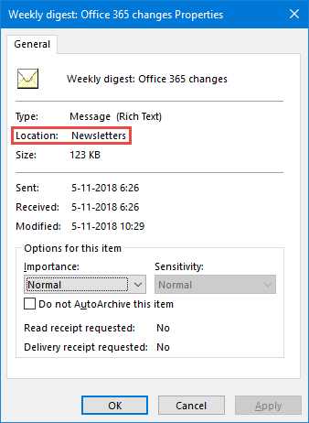  
*The old Properties dialog still holds some useful information.*